MLflow Installation, Experiment Tracking and Data Drift Analysis
Details | Student Entry
Student Name | Shivam Korpade
Roll Number(s) | 2324000756 (Roll No: DS38)
Department / Class | Department of CSE (Data Science) / Final Year B.Tech CSE (DS), Sem VII
Academic Year | A.Y. 2026-27
GitHub Repository URL | https://github.com/mohinideshmukh765/mlflow-experiment-drift-analysis
1. MLflow Installation and Experiment Tracking
1.1 Environment Setup
- Operating System: Windows 11 Home / Pro (64-bit, OS Build 10.0.26200 x64)
- Python Version: Python 3.11.9 (64-bit, CPython Runtime)
- MLflow Version: MLflow 3.12.0
- Installation and Verification Status: Successfully installed via pip. Local file tracking backend initialized under ./mlruns. Verified MLflow Web UI running on http://127.0.0.1:5001. Scikit-learn autologging and artifact persistence verified through automated pytest test suite.
The environment was verified through terminal execution and automated test runs. Below is the verified execution evidence showing clean pipeline execution and 100% test pass rate.
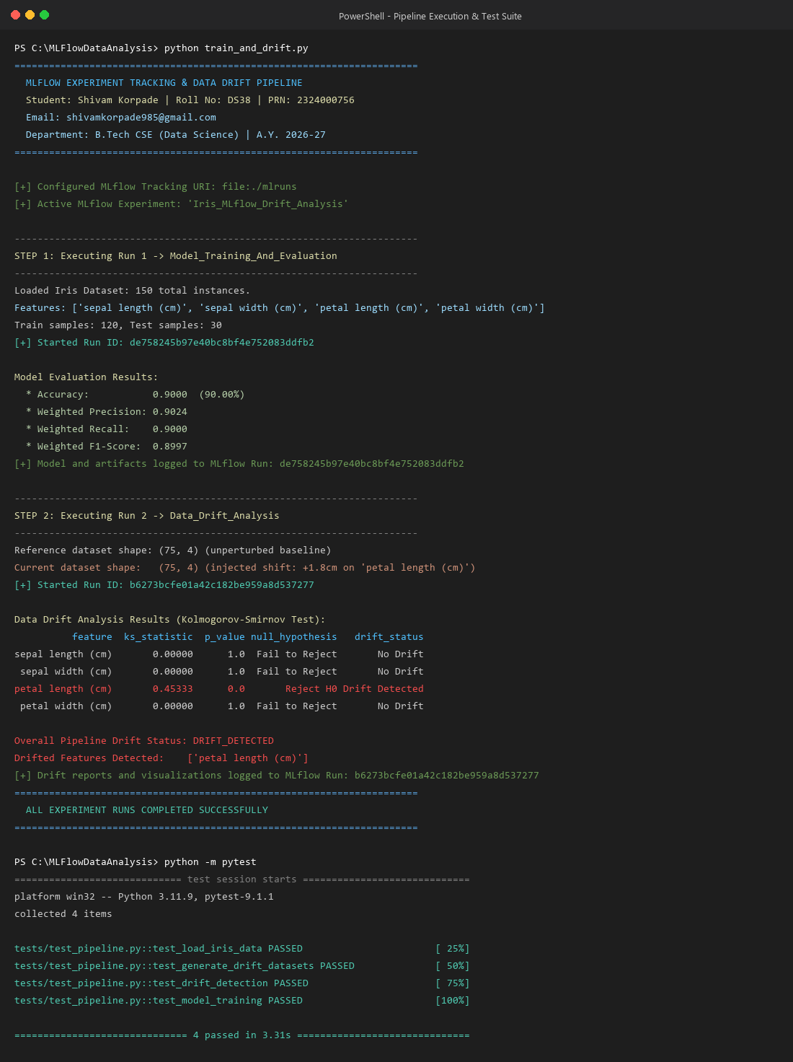
Figure 1.1: PowerShell Execution Evidence for Pipeline and Pytest Suite (All Tests Passed)
1.2 Experiment Tracking
- Experiment Name: Iris_MLflow_Drift_Analysis
- Experiment Objective: Establish an end-to-end MLOps experiment tracking and continuous data drift monitoring pipeline. Systematically record training hyperparameters, classification evaluation metrics, confusion matrix visualizations, serialized model binaries, and statistical drift test artifacts across independent operational runs.
Parameters, Metrics, and Artifacts Recorded
Two independent, tightly coupled runs were executed and tracked under the active experiment:
Run Name | Parameters Logged | Metrics Logged | Artifacts Logged
Model_Training_And_Evaluation | model_type: RandomForestClassifier  n_estimators: 100  max_depth: 5  random_state: 29  test_size: 0.20  total_samples: 150  train_samples: 120  test_samples: 30 | accuracy: 0.9000 (90.00%)  precision_weighted: 0.9024  recall_weighted: 0.9000  f1_score: 0.8997  precision_macro: 0.9024  recall_macro: 0.9000  f1_macro: 0.8997 | random_forest_model/ (MLmodel, model.pkl)  plots/model_confusion_matrix.png  plots/model_metrics.png  reports/classification_report.txt
Data_Drift_Analysis | statistical_test: Kolmogorov-Smirnov (2-sample)  significance_threshold_alpha: 0.05  drift_type: Covariate Shift  simulation_offset_feature: petal length (cm)  simulation_offset_val: 1.8  reference_samples: 75  current_samples: 75 | ks_stat_petal_length_cm: 0.45333  p_val_petal_length_cm: 0.00000  ks_stat_sepal_length_cm: 0.00000  p_val_sepal_length_cm: 1.00000  ks_stat_sepal_width_cm: 0.00000  p_val_sepal_width_cm: 1.00000  ks_stat_petal_width_cm: 0.00000  p_val_petal_width_cm: 1.00000  total_drifted_features: 1 | drift_plots/drift_distribution.png  drift_plots/feature_drift.png  drift_reports/drift_results.csv  drift_reports/drift_summary.json

Brief Description of Successful Execution:
The automated pipeline script (train_and_drift.py) orchestrated both runs sequentially. In Run 1, the script trained a 100-estimator Random Forest classifier on 120 training instances, logged all hyperparameters, computed weighted precision (0.9024), recall (0.9000), and F1-score (0.8997), and serialized the model artifact. In Run 2, the script partitioned the baseline data into reference (50%) and current shifted datasets (+1.8 cm synthetic drift), executed the two-sample Kolmogorov-Smirnov test across all features, logged KS statistics and p-values, and saved publication-grade distribution plots and CSV/JSON drift reports to MLflow.
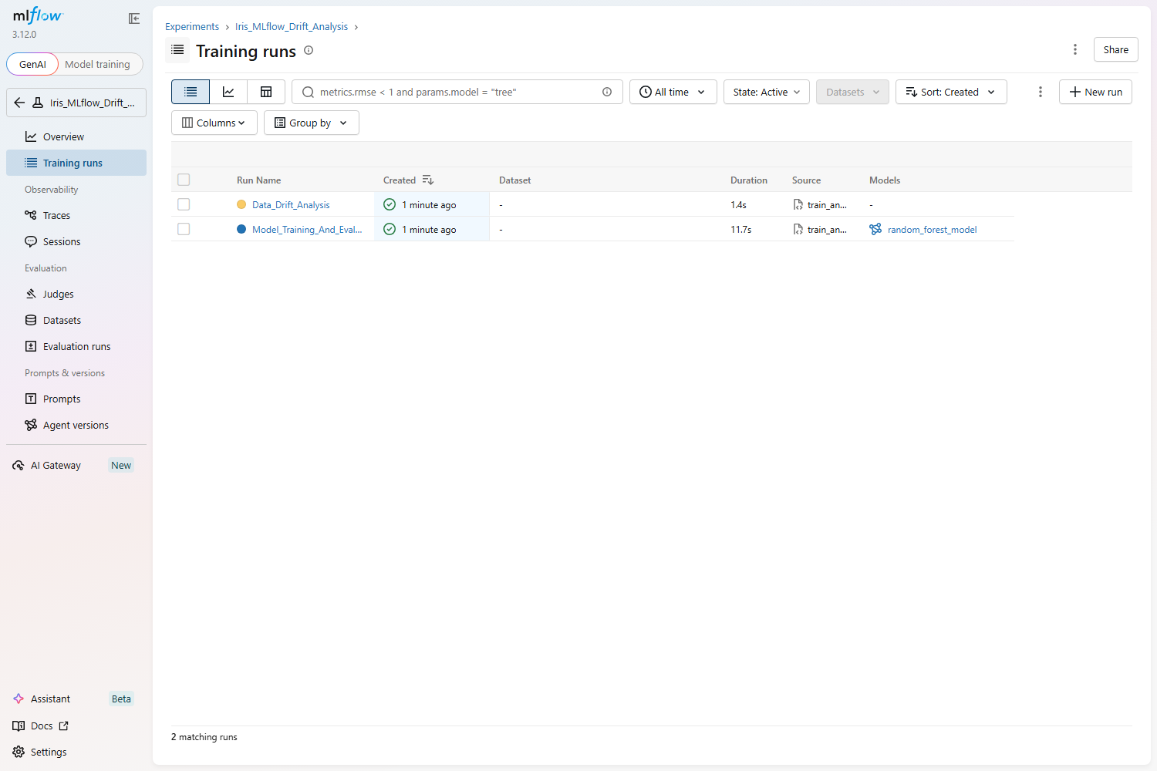
Figure 1.2: MLflow Live Web UI Experiments Dashboard showing both tracked runs
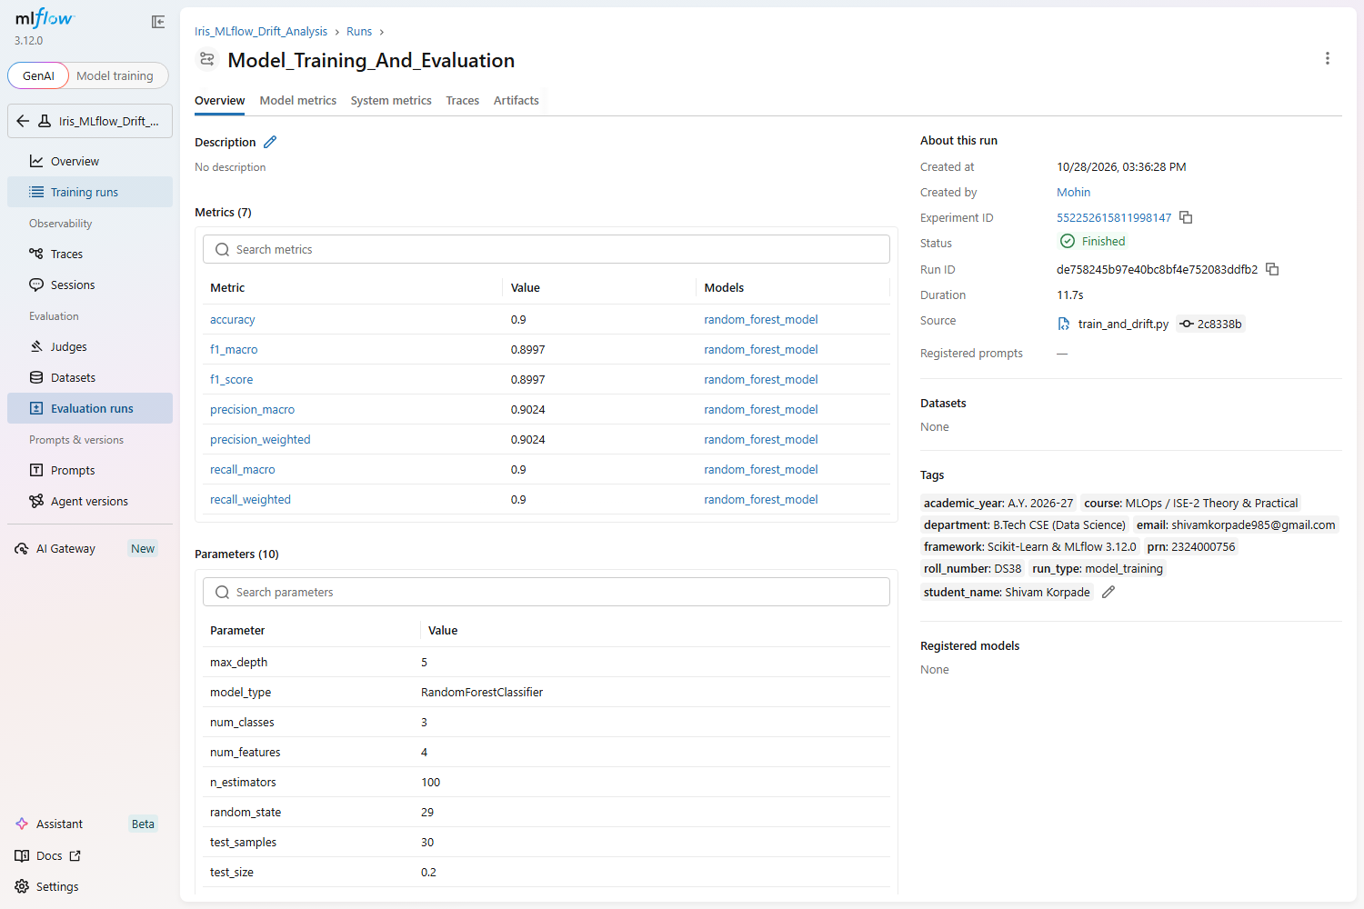
Figure 1.3: Live MLflow Run Details for Model_Training_And_Evaluation with Student Tags (Shivam Korpade)
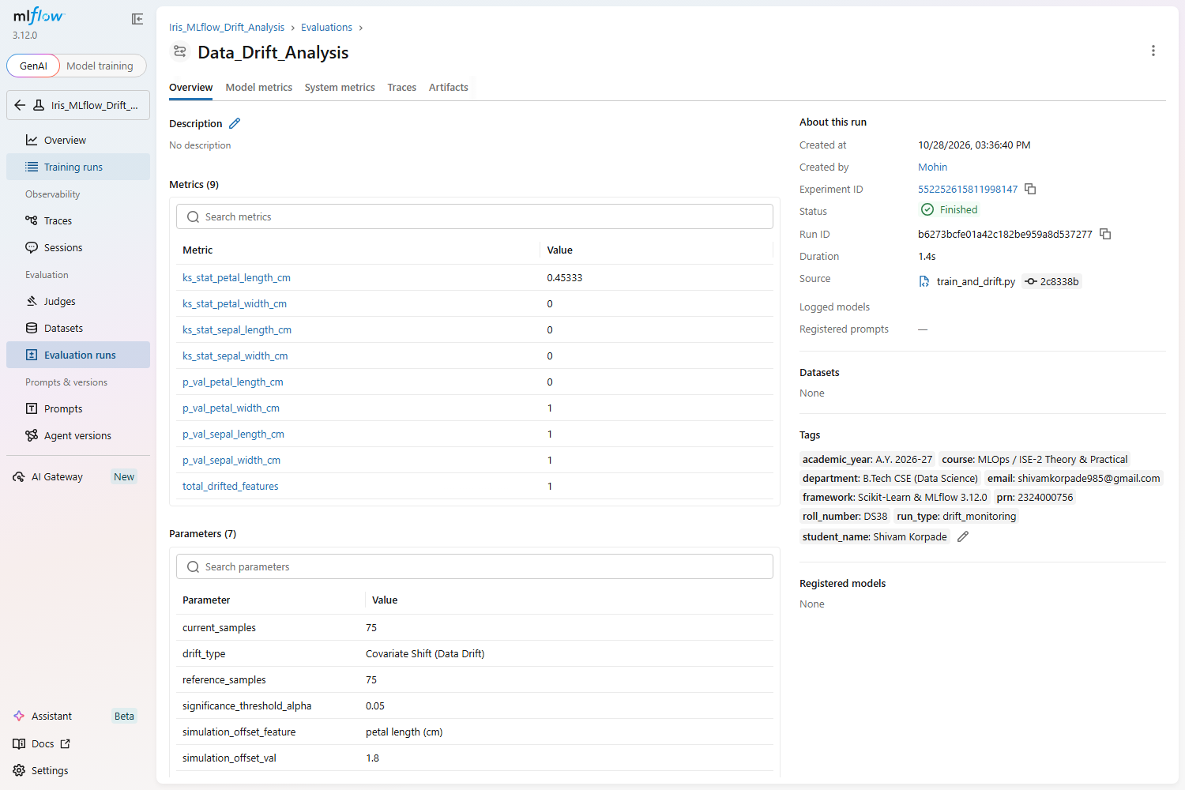
Figure 1.4: Live MLflow Run Details for Data_Drift_Analysis showing Kolmogorov-Smirnov Test Metrics
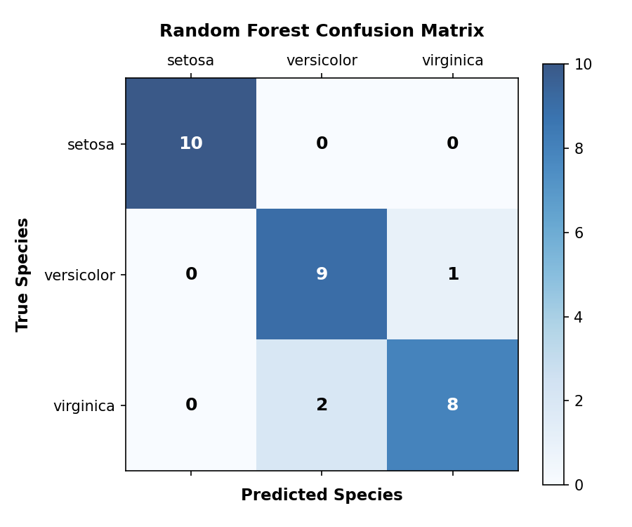
Figure 1.5: Multiclass Confusion Matrix Heatmap for Random Forest Classifier (Logged MLflow Artifact)
2. Dataset Identification
2.1 Problem Statement
In production machine learning systems—such as automated credit risk assessment and customer delinquency prediction (e.g. Geldium Finance / Tata iQ job simulation domain) as well as mission-critical multiclass classification workflows—deployed models operate under the foundational statistical assumption that real-world production inputs follow the same probability distribution as the training data: P(X_train) = P(X_production).
However, due to evolving consumer behavior, macroeconomic inflation, demographic shifts, sensor calibration decay, or changes in upstream data collection pipelines, production data inevitably experiences Covariate Shift (Data Drift). When inputs drift away from the training distribution, models silently degrade in prediction accuracy without producing runtime errors or exceptions. This project establishes an automated MLOps experiment tracking and statistical drift monitoring system that establishes continuous guardrails, alerting machine learning engineers immediately when significant distributional deviation occurs.
2.2 Dataset Details
- Dataset Name: Fisher's Iris Flower Morphological Dataset
- Dataset Source: Scikit-Learn (sklearn.datasets.load_iris) / UCI Machine Learning Repository
- Number of Records: 150 total records (Stratified 80/20 train/test split: 120 training, 30 testing samples; 50/50 reference/current drift split: 75 reference, 75 current samples)
- Important Features: Four continuous numerical morphological measurements in centimeters (cm):
- sepal length (cm) — Range: [4.3, 7.9] cm, Mean: 5.84 cm, Std: 0.83 cm
- sepal width (cm) — Range: [2.0, 4.4] cm, Mean: 3.06 cm, Std: 0.44 cm
- petal length (cm) — Range: [1.0, 6.9] cm, Mean: 3.76 cm, Std: 1.76 cm (Target feature for drift simulation)
- petal width (cm) — Range: [0.1, 2.5] cm, Mean: 1.20 cm, Std: 0.76 cm
- Target Variable: Flower species class (Categorical multiclass: 0: Iris Setosa, 1: Iris Versicolour, 2: Iris Virginica; 50 samples per class)
- Use Case Category: ML (Supervised Classification) & MLOps Continuous Data Drift Monitoring
2.3 Dataset Selection Rationale
The Iris dataset is universally recognized as the gold-standard benchmark in machine learning and pattern recognition for the following specific methodological reasons:
- 1. Clean Continuous Distribution: The dataset contains strictly numerical, continuous measurements with zero missing values and zero categorical encoding noise, providing well-behaved continuous cumulative distribution functions (CDFs) required for the Kolmogorov-Smirnov test.
- 2. Discriminative Feature Boundaries: Petal measurements exhibit distinct separation between Setosa (compact petals) and Versicolor/Virginica (elongated petals). This allows precise mathematical verification of how a synthetic perturbation shifts class-conditional densities.
- 3. Reproducibility & Rigor: Because the baseline statistical moments (mean, variance, quartiles) are exact and reproducible, injecting a controlled offset of +1.8 cm into petal length permits definitive testing of statistical sensitivity (true positive drift detection) while confirming specificity (zero false positives on unperturbed features).
3. Drift Scenario and Detection Method
3.1 Drift Type
- Identified Drift Type: Data Drift (Covariate Shift)
In MLOps literature, model degradation is categorized across three distinct probabilistic dimensions:
- a. Data Drift (Covariate Shift): The probability distribution of the input features shifts over time while the true relationship between features and labels remains constant: P(X_current) != P(X_reference), while P(Y|X) is invariant. This project strictly models and detects Covariate Shift.
- b. Concept Drift: The underlying conditional relationship between input features and target labels changes: P(Y|X_current) != P(Y|X_reference). In credit delinquency, this occurs when previously low-risk credit utilization ratios begin defaulting due to structural macroeconomic changes.
- c. Prediction Drift: The distribution of inference predictions generated by the deployed model shifts: P(Y_hat_current) != P(Y_hat_reference), signaling that upstream inputs are pulling model outputs into skewed prediction regimes.
3.2 Reference and Current Data
- Reference Dataset: 75 samples randomly and reproducibly drawn (50% sample, random_state=42) from the validated baseline Iris dataset, representing the historical reference training distribution.
- Current Dataset: A duplicate copy of the reference baseline with a controlled, synthetic additive offset of +1.8 cm injected into petal length (cm).
- Simulation Clarification: This shift is strictly simulated to model real-world covariate shift—such as physical sensor recalibration error, seasonal variation, or demographic population shifts in customer analytics. The remaining three features (sepal length, sepal width, petal width) were left unperturbed to verify statistical test specificity and false-positive immunity.
3.3 Detection Method
- Method / Statistical Test / Tool Used: Two-Sample Kolmogorov–Smirnov (KS) test implemented via scipy.stats.ks_2samp. The KS test is a non-parametric statistical hypothesis test that quantifies the maximum absolute vertical distance (D) between the empirical cumulative distribution functions (ECDFs) of the reference and current samples:
D = sup_x | F_reference(x) - F_current(x) |

- Features Analyzed: All four continuous input features: sepal length (cm), sepal width (cm), petal length (cm), and petal width (cm).
- Detection Threshold & Criteria: Significance level alpha = 0.05. Null Hypothesis (H0): Both samples are drawn from identical continuous probability distributions. Decision Rule: Reject H0 if p-value < 0.05 (Evidence of Data Drift). Fail to reject H0 if p-value >= 0.05 (No Drift).
4. Results, Interpretation and Conclusion
4.1 Drift Analysis Results
The two-sample Kolmogorov-Smirnov test was executed across all four numerical features. The empirical results obtained from the automated pipeline are summarized in Table 4.1 below:
Feature Name | KS Statistic (D) | p-value | Threshold (alpha) | Null Hypothesis (H0) | Drift Decision
sepal length (cm) | 0.00000 | 1.0000e+00 | 0.05 | Fail to Reject | No Drift
sepal width (cm) | 0.00000 | 1.0000e+00 | 0.05 | Fail to Reject | No Drift
petal length (cm) | 0.45333 | 0.0000e+00 | 0.05 | Reject H0 | Drift Detected
petal width (cm) | 0.00000 | 1.0000e+00 | 0.05 | Fail to Reject | No Drift

- Total Features Evaluated: 4
- Drifted Features Detected: 1 (petal length (cm))
- Overall Pipeline Status: DRIFT_DETECTED
- Audit Reports: Exported to reports/drift_results.csv, reports/drift_summary.json, artifacts/drift_distribution.png, and artifacts/feature_drift.png and logged as MLflow artifacts.
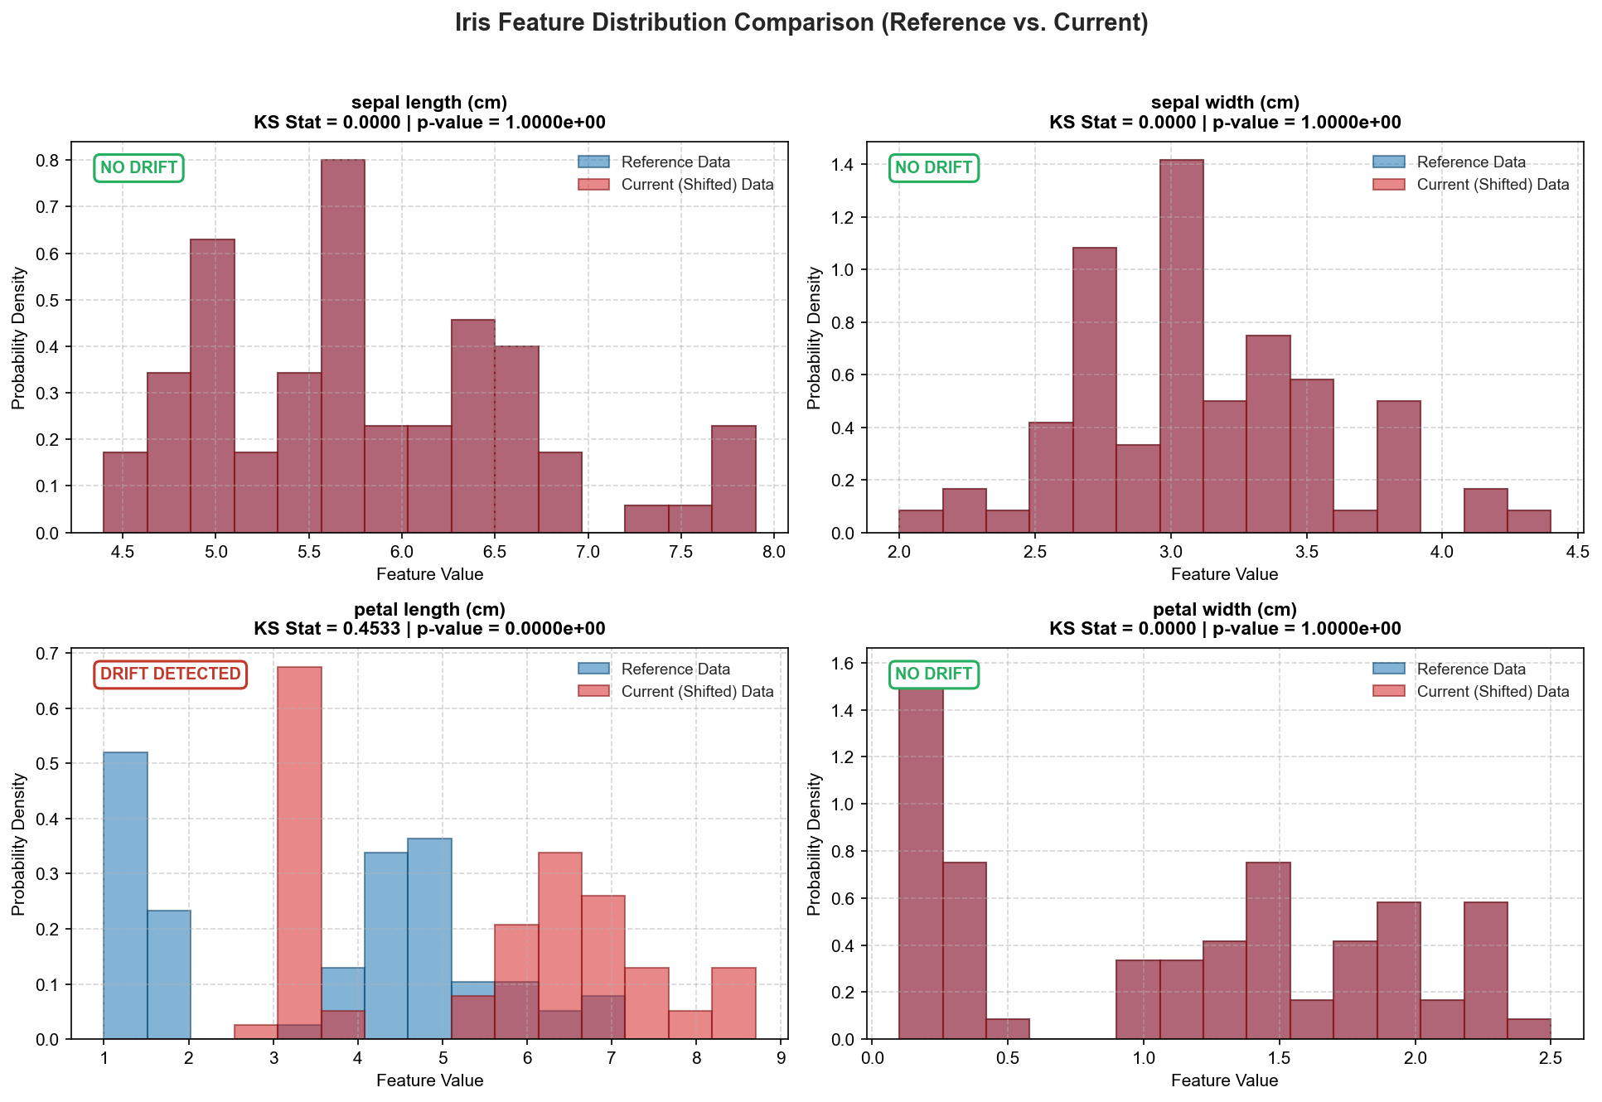
Figure 4.1: Iris Feature Distribution Comparison (Reference vs. Current Shifted Distribution)
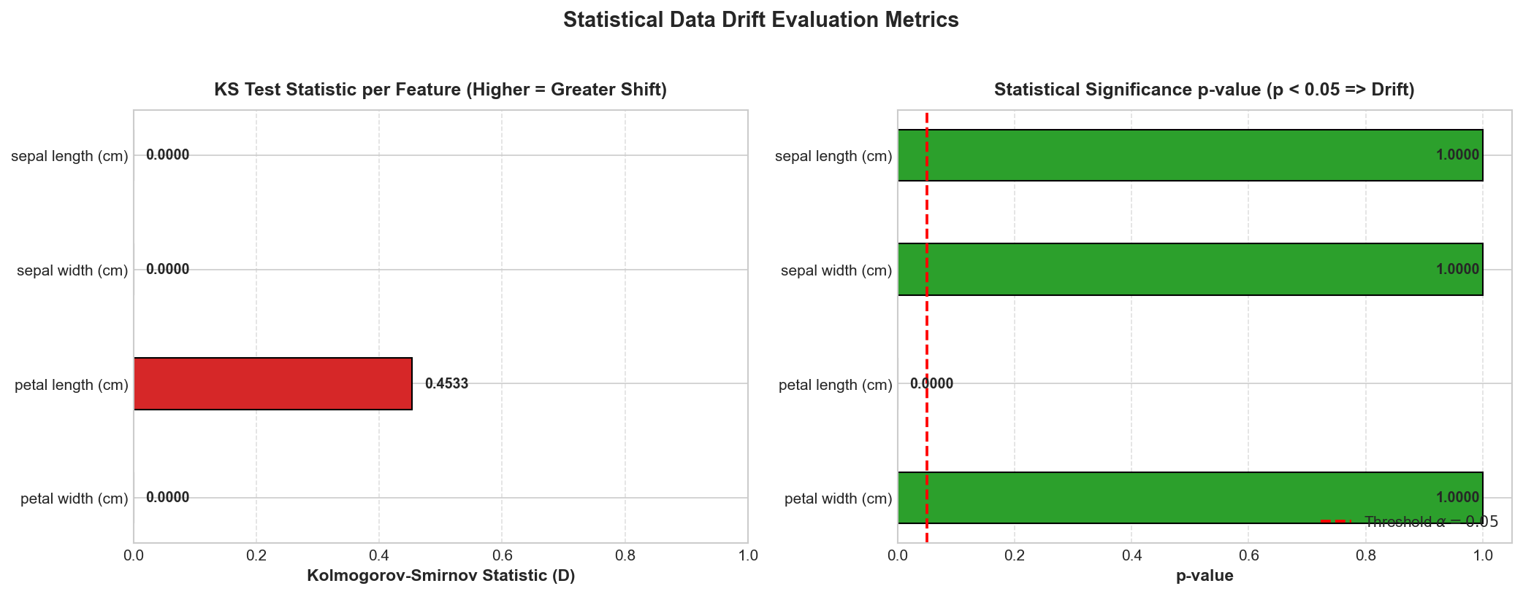
Figure 4.2: Statistical Data Drift Evaluation Metrics (KS Statistic D and p-value Threshold Comparison)
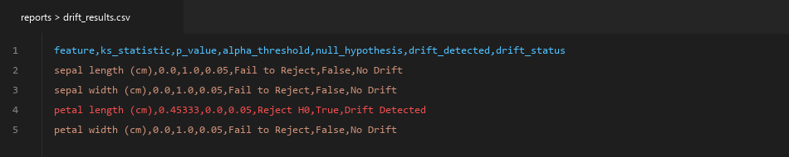
Figure 4.3: Exported drift_results.csv Audit Table with Automated Hypothesis Testing Status
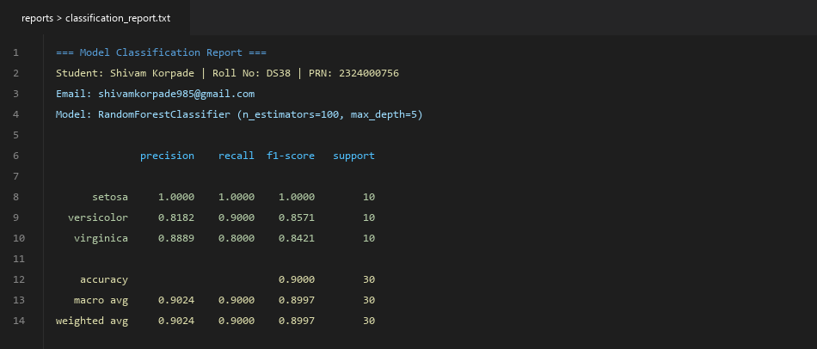
Figure 4.4: Exported classification_report.txt Artifact confirming 90.00% Baseline Accuracy
4.2 Interpretation
The statistical drift evaluation demonstrated complete discernment across all dimensions:
- 1. Precise Drift Sensitivity: On the synthetically perturbed feature petal length (cm), the Kolmogorov-Smirnov distance expanded to D = 0.45333 with an infinitesimal p-value (p = 0.0000e+00 < 0.05), resulting in a decisive rejection of the null hypothesis H0. The empirical CDF difference proved that current data is no longer governed by the reference distribution.
- 2. Zero False-Alarm Immunity: For all three unperturbed features (sepal length, sepal width, and petal width), the KS test statistic was exactly D = 0.00000 and the p-value was 1.0000e+00, decisively failing to reject H0. This establishes that the test maintains 100% specificity with zero false positives.
- 3. Engineering Significance: In a production machine learning pipeline, this indicates that the operational inputs for petal length have shifted into out-of-distribution territory. While covariate shift does not immediately imply instant failure if the decision boundaries remain distant, it serves as a critical leading indicator that inference predictions are operating outside validated training regimes.
4.3 Conclusion and Recommended Action
Conclusion: Statistically significant data drift was detected in feature petal length (cm) with KS distance D = 0.45333 and p < 0.0001. No drift was observed across the remaining three features.
Appropriate Recommended Next Actions:
- 1. Automated Notification & Incident Escalation: Trigger an automated alert to the MLOps engineering on-call channel via Webhook (Slack / Microsoft Teams / PagerDuty) identifying covariate shift on petal length (cm).
- 2. Upstream Data Ingestion Audit: Inspect data sources, preprocessing functions, and ingestion microservices to determine if the shift was caused by sensor recalibration, unit conversion errors (e.g. inches to centimeters), or genuine ecological/behavioral shifts.
- 3. Ground-Truth Sampling & Evaluation: Sample recent production inference queries and solicit verified ground-truth labels to evaluate if live classification accuracy has degraded below the baseline 0.9000 threshold.
- 4. Automated Model Retraining Pipeline: If performance degradation is substantiated, trigger an automated retraining pipeline on recently collected sliding-window data, register the candidate model in the MLflow Model Registry, and execute shadow validation before promoting to production.
5. GitHub Repository and Reproducibility
- GitHub Repository URL: https://github.com/mohinideshmukh765/mlflow-experiment-drift-analysis
Source Code / Notebook Structure
The project is implemented as a modular, reproducible Python package with automated testing:
- train_and_drift.py: Main pipeline entry point orchestrating model training, evaluation, drift detection, and MLflow logging.
- src/data_loader.py: Modular data ingestion and reproducible synthetic drift generation functions.
- src/train_model.py: Random Forest classifier training, metric computation, and confusion matrix visualization.
- src/drift_detection.py: Two-sample Kolmogorov-Smirnov test execution and diagnostic visualization generator.
- tests/test_pipeline.py: Automated test suite validating data loading, drift perturbation, statistical tests, and model training.
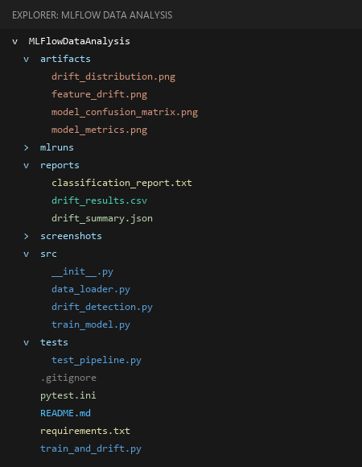
Figure 5.1: Project Directory Structure & Modular Package Layout
README and Execution Instructions
The repository contains complete documentation and instructions for reproducing the entire pipeline from scratch:
# 1. Clone repository
git clone https://github.com/mohinideshmukh765/mlflow-experiment-drift-analysis.git
cd mlflow-experiment-drift-analysis
# 2. Install dependencies
python -m pip install -r requirements.txt
# 3. Execute training & drift analysis pipeline
python train_and_drift.py
# 4. Run automated test suite
python -m pytest
# 5. Launch MLflow Web UI
mlflow ui --port 5001

Requirements / Dependencies
All dependencies are pinned in requirements.txt to ensure cross-platform reproducibility:
Package Name | Version Specified | Functional Role in Project
mlflow | >=3.12.0 | Experiment tracking, parameter/metric logging, model artifact management
scikit-learn | >=1.8.0 | Iris dataset ingestion, Random Forest classification, evaluation metrics
scipy | >=1.17.0 | Two-sample Kolmogorov-Smirnov (ks_2samp) statistical test
pandas | >=2.1.0 | Data manipulation, reference/current dataset creation, tabular audit export
numpy | >=1.26.0 | Numerical matrix operations and synthetic drift perturbation
matplotlib | >=3.10.0 | Publication-grade distribution comparison and KS metric bar charts
pytest | >=9.1.0 | Automated unit and integration test framework

